Ideas for Topic Activities
Summer Term 2 – Week 3: 15-19.06.20

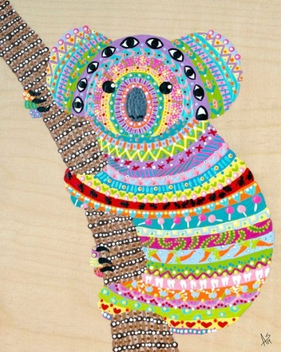
This week we would like you to focus on art and science!
Here are some lovely examples of aboriginal art. Can you recreate some aboriginal art or come up with your own based on your learning about Australia? Look carefully at the detail, the colours and the style and think carefully about what you will need or how you will achieve the same effect yourself!
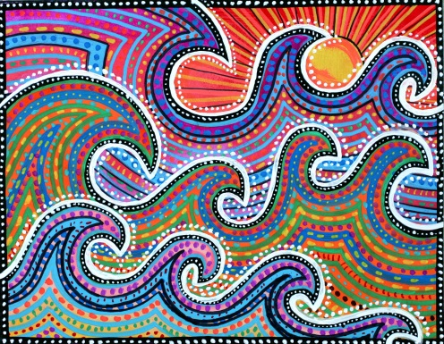
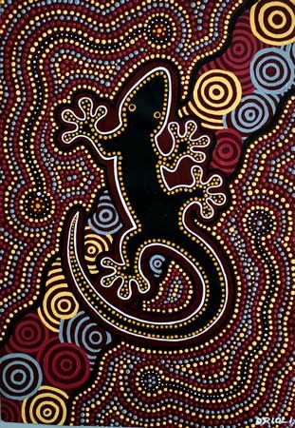

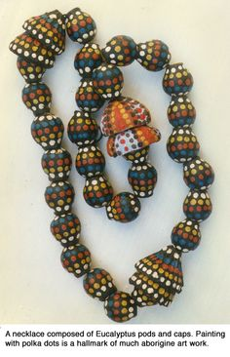
As well as beautiful art like the pictures above, there are lots of lovely aboriginal jewelleries and clothing like the ones below, as well as some wonderful instruments and boomerangs! Have a go at making something yourself using anything you have or can find at home.
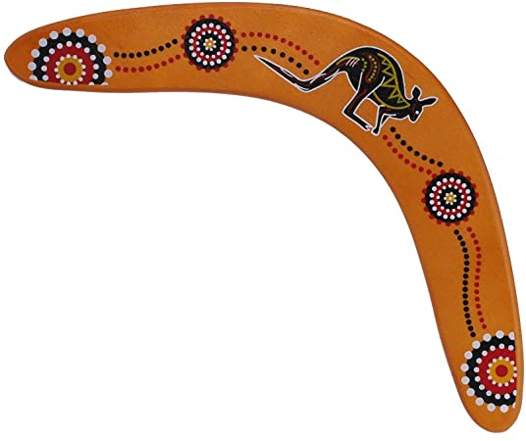
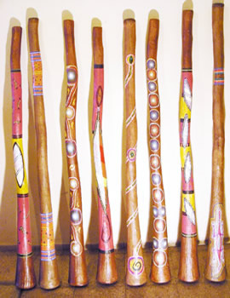
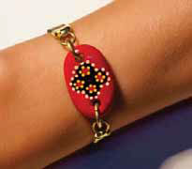

For science, can you find out about how we can make different colours using natural things? Remember to be safe – do not pick anything up without knowing what it is or without a grown up and never put your fingers into your mouth whilst using plants and berries for art.
Some ideas –
- Crushed grass
- Squashed berries
- Herbs and spices (can be from your cupboard but remember that somewhere in the world they will grow naturally outside!)
- Crushed stones/ sands
- Soil
- Flower petals/ the inside of flowers
- Fruits and vegetables

Can you use your natural colours to make some art or dye some fabric? Or just have fun with nature!

