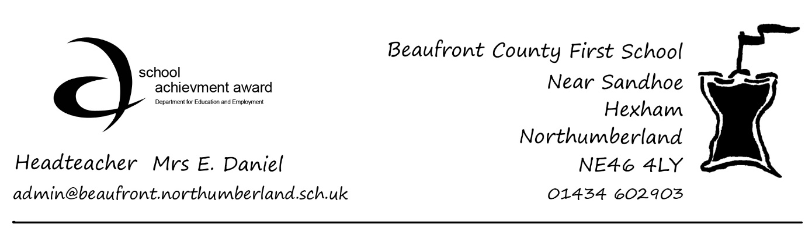
22.3.20

Coronavirus (COVID-19) –Latest Update

On Friday, the Government provided further guidance to schools and parents on school closures. The full guidance can be found on the Department for Education Website https://www.gov.uk/government/publications/closure-of-educational-settings-information-for-parents-and-carers.

The Government is emphasising the following key point to parents:

- If it is at all possible for children to be at home, then they should be, to limit the chance of the virus spreading.

- For children who need specialist support, are vulnerable or have a parent who is a “critical worker”, then the Government is asking schools to remain open to provide care for a limited number of children, but only for those who absolutely need to attend. The fewer children making the journey to school, and the fewer children in educational settings, the lower the risk that the virus can spread and infect vulnerable individuals in wider society.

- Parents should not rely for childcare upon those who are advised to be in the stringent social distancing category such as grandparents, friends, or family members with underlying conditions.

- Parents should also do everything they can to ensure children are not mixing socially in a way which can continue to spread the virus. They should observe the same social distancing principles as adults.

- Vulnerable children include children who are supported by social care, those with safeguarding and welfare needs, including child in need plans, on child protection plans, ‘looked after’ children, young carers, disabled children and those with education, health and care (EHC) plans.

- If your work is critical to the COVID-19 response, or you work in one of the critical sectors set out on the DfE website referred to above, and you cannot keep your child safe at home, then your children will be prioritised for education provision.

What you need to do if you are a parent who works in one of the key sectors and cannot keep your child safe at home

We believe that we have been in touch with the parents of all children who are “vulnerable” within the meaning set out above. We also believe that we have been in touch with the parents of all children who we understand to work in one of the key sectors, though as the guidance was not issued until Friday we appreciate that it is possible some have not been contacted.

If you believe that your child comes within either of categories for which provision is to be made but you have not already made clear your intentions for the forthcoming period, please contact Mrs Daniel as a matter of urgency via [admin@beaufront.northumberland.sch.uk ]

We fully support the Government’s efforts to limit the spread of the virus through distancing measures and it is our duty to protect our own staff. We may need to seek evidence that your child is entitled to be in School. Our intention is that provision at school will involve a skeletal staff who will supervise children undertaking the learning activities that have already been set, during ordinary school hours. We will discuss on an individual case by case basis any care required before or after school. We will be unable to provide lunch and any children attending will need to provide a packed lunch, save that in the case of children who have free school meals, a packed lunch will be provided.

Thank you very much all the parents who have already been in touch.

Please note that this is a continually evolving situation. It is expected that further guidance will be issued by Northumberland County Council, who may decide in due course to use just one of the schools within the Hexham Partnership as the venue for provision.

Thank you for your continued support.

Elizabeth Giuliani (Chair of Governors)
Eileen Daniel (Head Teacher)

