
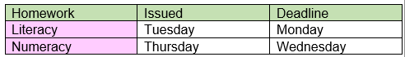
Spring 1 2022
Music
We will be learning about musical terminology alongside learning simple sequences on the glockenspiel.

French
This ‘food’ themed unit uses a story as inspiration for children to learn and apply French food vocabulary.

Additional Information
Homework will be given and explained to children at two points in the week.

Homework is chosen to reinforce learning from previous learned tasks or to research and explore new topics. We select work specifically to enhance and build on ‘in school’ learning.
Occasionally work may be online based, for example, Mathletics. If you are unsure of your child’s logins please get in touch and we can reissue these.

Children are working on their reading fluency and understanding of texts. We encourage you to read as much as possible with children at home. Mrs Hawkins has set up an incentive for children in class. It’s helpful to ask about challenging vocabulary and themes to see if your child fully understands their book.

Computing and Digital Literacy
Children will discuss and develop their internet safety and use Safer Internet Day as a stimuli.
In Computing session children will use Scratch to allow them to develop and create their own animations.

Art
We will be investigating pattern and creating our own rainforest watercolour painting, based on the inspirational works of Henri Rousseau.

