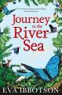
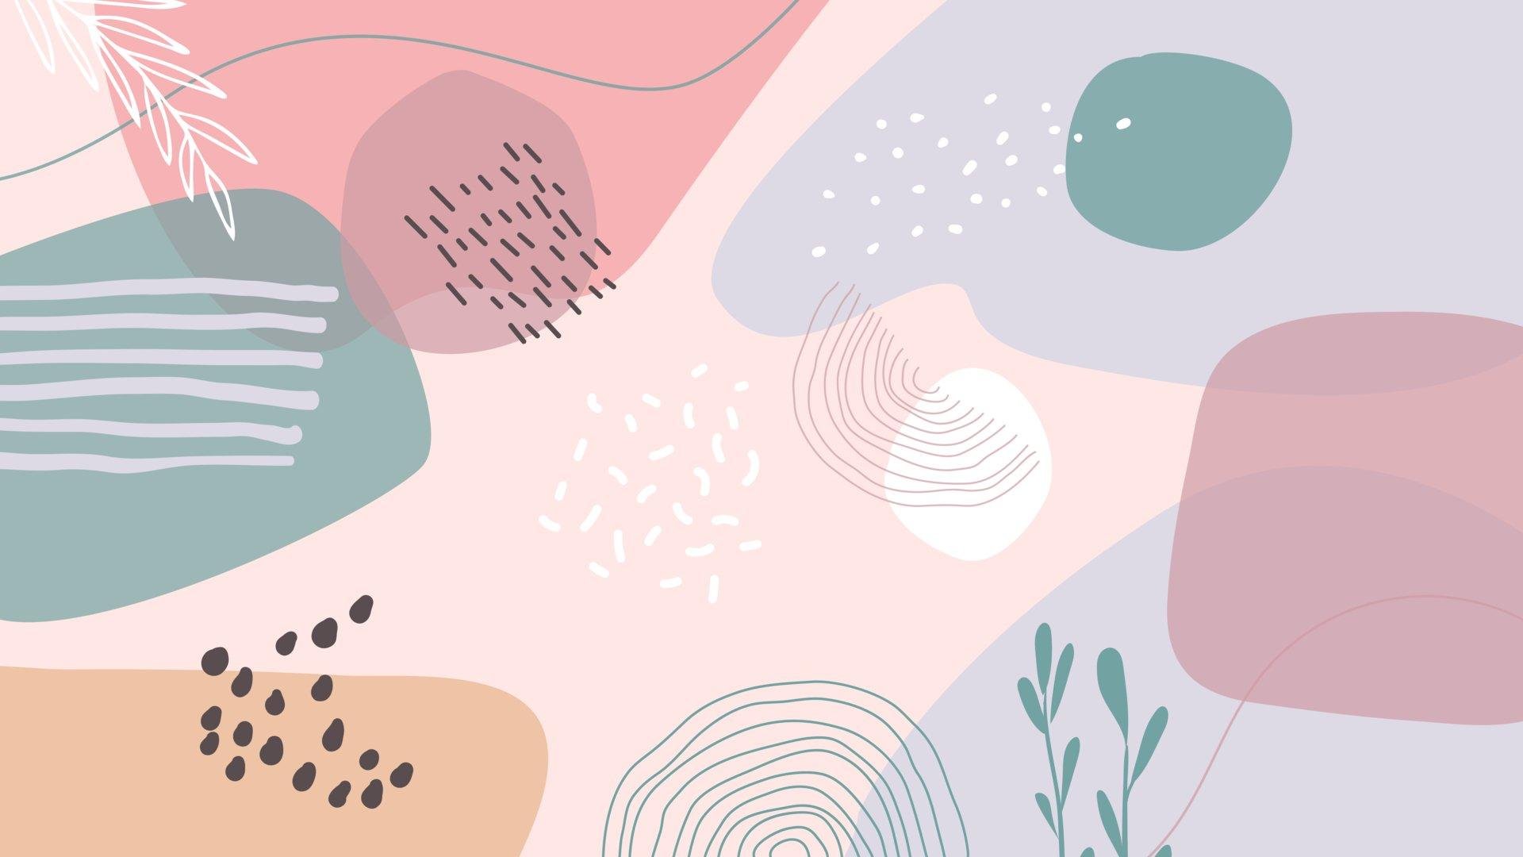
Spring 1 2022
Numeracy
We will be covering the White Rose Maths units;
Multiplication and Division
Length, area and perimeter
Money Y3

Recommended Home reader (read with your child)
The Journey to the river sea by Eva Ibbotson

Science
Living things and their Habitats
We will look at how we can classify living things using their characteristics
Looking at where and why they live in certain habitats
We will look at potential hazards to these habitats and what it would mean for the things that live there.

Literacy
To link with our Rainforest theme, we will begin by using a narrative written by Lynne Cherry called ‘The Great Kapok Tree’.
We will have a class novel called ‘The Explorer’ by Katherine Rundell. Tasks each week will be drawn from this text and themes associated with it.
We will also do daily/weekly reading, spelling and grammar activities.

Geography
Fantastic Forests
We will be looking into rainforests, specifically the Amazon. We will look at the structure and geography of the rainforest and the animals, ecosystems and people that live there.
We will look at the threats to the rainforest and how it impacts our earth.
We will look at forests and woodlands in our countryside and make comparisons.
Religious Education and PSHE
What is the Bible and why is it important to Christians?
Going for goals- How can we be ambitious and achieve what we would like to?

PE
We will continue our weekly swimming session on Tuesday afternoons.
We will learn games involving tactics and develop our skills. (Friday PM)

